**ASSIGNMENTS**

|  |  |
| --- | --- |
| **NAME** | **PRIYADHARSHINI K** |
| **DEPARTMENT** | **BIOMEDICAL ENGINEERING** |
| **NM ID** | **6DAE8EC4CB712B79C934164B1F098745** |
| **NM COURSE** | **DIGITAL MARKETTING** |
| **COLLEGE** | **DHANALAKSHMI SRINIVASAN INSTITUTE OF TECHNOLOGY** |

**ASSIGNMENT 1:**

**Create a blog or website using Blogspot and word press:**

**Word press**

**URL:**[**https://wordpress.com/view/riyaboutiqueandreadymades.wordpress.com**](https://wordpress.com/view/riyaboutiqueandreadymades.wordpress.com)

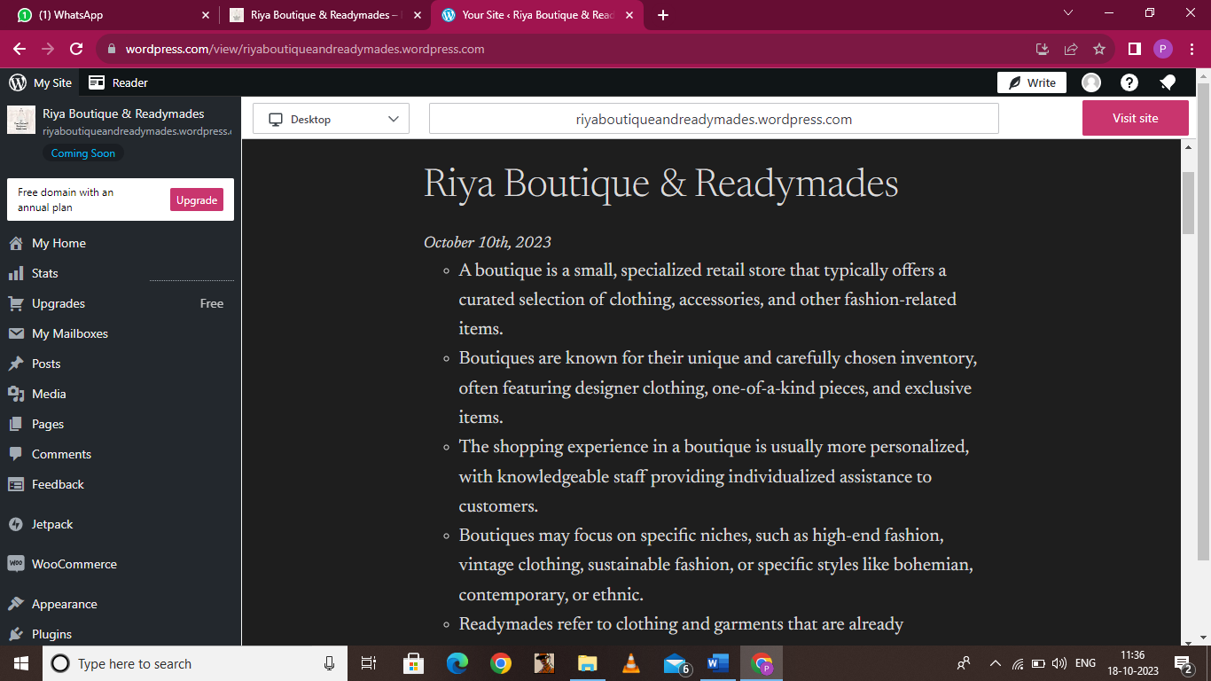

**Blogspot**

**URL:** [**https://www.blogger.com/blog/posts/4491606988941959350**](https://www.blogger.com/blog/posts/4491606988941959350)

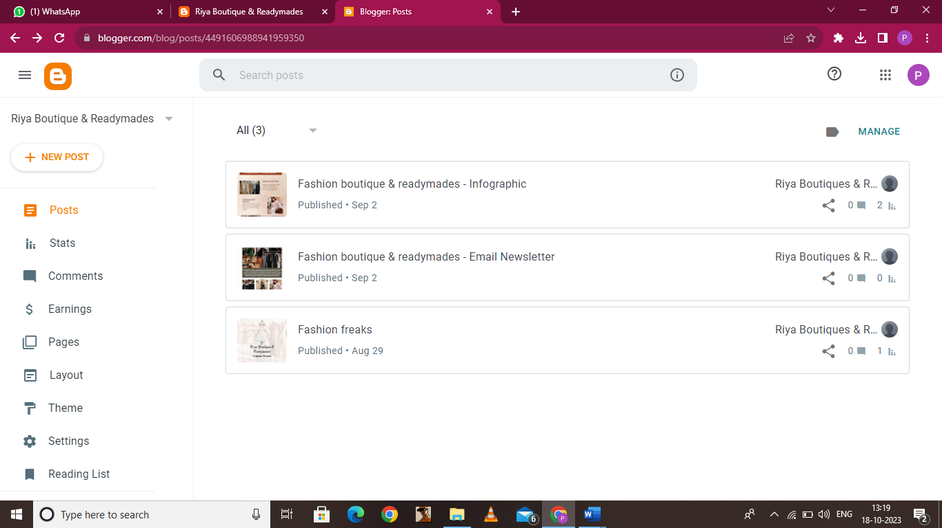

**ASSIGNMENT 2:**

**Create a new Facebook business page and post one social media poster for your brand.**

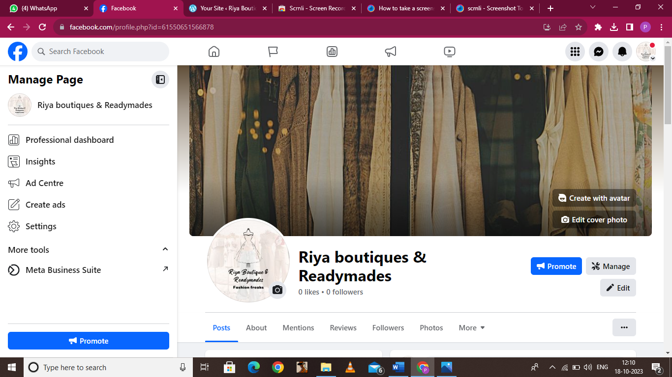**URL:** [**https://www.facebook.com/riyaboutiqueandreadymades/**](https://www.facebook.com/riyaboutiqueandreadymades/)

**ASSIGNMENT 3:**

**Create and design a advertisement poster using Canva.**

**URL:**[**https://www.facebook.com/photo/?fbid=122111424416021718&set=a.122111424566021718**](https://www.facebook.com/photo/?fbid=122111424416021718&set=a.122111424566021718)

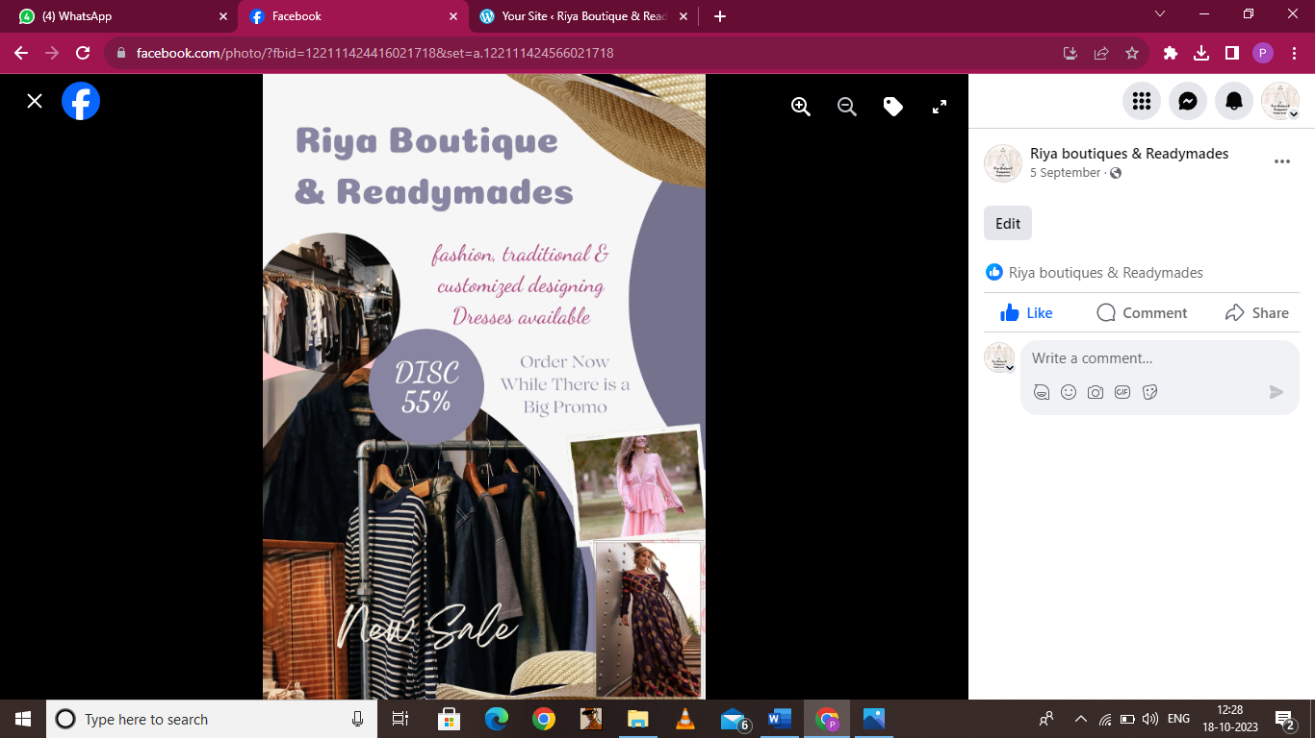

**ASSIGNMENT 4:**

**Create an E mail newsletter design using Mailchimp or Canva tool.**

**URL:** [**https://riyafashionboutiques.blogspot.com/2023/09/fashion-boutique-readymades-email.html**](https://riyafashionboutiques.blogspot.com/2023/09/fashion-boutique-readymades-email.html)

